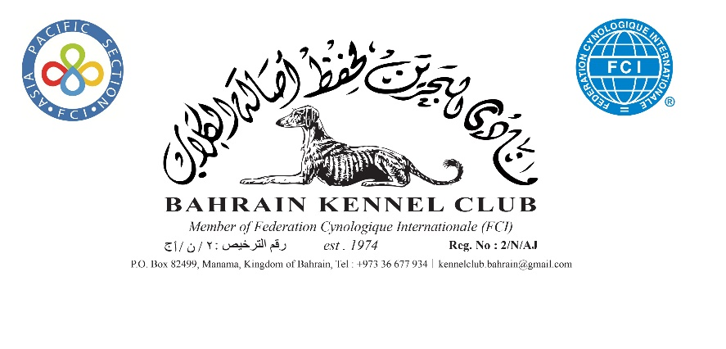

General Code of Ethics

Breeders / Owners

1 | Will properly house, feed and water and exercise all dogs under their care and arrange for appropriate veterinary attention of and when require. | 8. | Will clean up after their dogs in public places or anywhere their dogs are being exhibited
2. | Will agree without reservation that any veterinary surgeon who performs an operation on any of their dogs which alters the natural conformation of the animal, should report such operations to the Bahrain Kennel Club | 9. | Will only sell dogs where there is a reasonable expectation of a happy and healthy life and will help with the re-homing of a dog if the initial circumstances change
3. | Will agree that no healthy puppy will be culled. Puppies which may not conform to the Breed Standard should be placed in suitable homes | 10. | Will supply written details of all dietary requirements and give guidance concerning responsible ownership when placing dogs in a new home
4. | Will abide by all aspects of the Animal Welfare law of Kingdom of Bahrain | 11. | Will ensure that all relevant Bahrain Kennel Club documents are provided to the new owner when selling or transferring a dog, and will agree, in writing, to forward any relevant documents at the earliest opportunity, if not immediately available
5. | Will agree not to breed from a dog or bitch which could be physically and mentally in any way harmful to the dog or to the breed. The breeder must ensure that the animals he intends to use for breeding have stable temperament and are in good physical condition. | 12. | Will not sell any dog to commercial dog wholesalers, retail pet dealer or directly or indirectly.
6. | Will not allow any of their dogs to roam at large or to cause nuisance to neighbors or those carrying out official duties | 13. | Will not sell or auction Bahrain Kennel Club registration certificates as stand alone items (not accompanying a dog)
7. | Will ensure that their dogs wear properly tagged collars and will be kept leased or under effective control when away from home | 14. | Will not knowingly misrepresent the characteristics of the breed nor falsely advertise dogs nor mislead any person regarding the health or quality of a dog

Breach of these provisions may result in disciplinary action by Bahrain Kennel Club and/or reporting to the relevant authorities for legal action, as appropriate.

