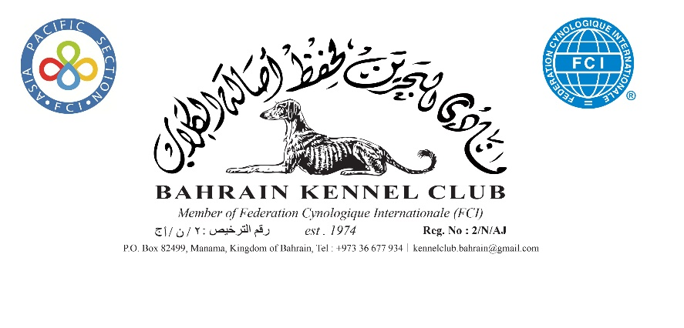

Change of Ownership

I confirm the change of registered ownership of the dog detailed below :
Note : All boxes has to be filled in and sent to BCK
Together with Original Pedigree and Copy of CPR

Previous Owner :
Dogs Registered Name
Dogs Registration Number
Microchip and /or Tattoo Number
Owned By
Membership Number
Signature
Date

The new owner information :
Full Name
Address
Membership Number
Telephone number(s) :
Email Address
Signature
Date

The transfer of registered ownership fee is Bahraini Dinars Ten only BD 10.000 and should be paid in full on collection of the new ownership document. A CPR copy of Previous and New owner must be attached.

The registration form can be E-mailed kennelclub.bahrain@gmail.com or send via post P.O. Box 82499. Note : The original pedigree has to be submitted to BKC before a change of ownership will be approved. For further information please call +973 36677934.
If you do NOT like BKC to share your contact details, Please tick the box

