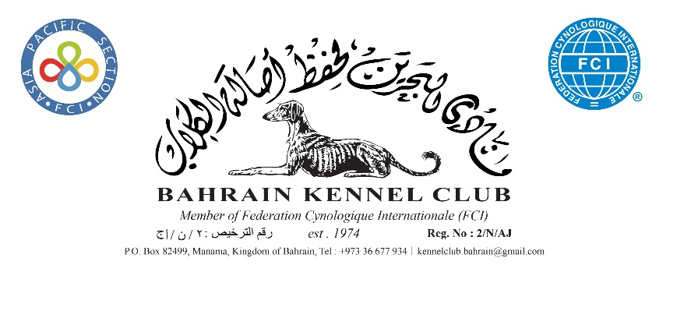

MEMBERSHIP RENEWAL FORM 2022

Name
Member No.
Address
Mobile
Email

I agree to abide by the Memorandum and Article of Association of Bahrain Kennel Club Rules and by the bye-laws, rules and regulations made by Bahrain Kennel Club (all as amended from time to time) including in particular but without limitation, the disciplinary provisos set out in the Article of Association
Signature……………………………………………………………….. | Date ……………………………..
To be returned no later than 31st December 2021

If you do not wish your details to be passed to third parties, please tick the box

